2024 PyTRIM Architecture and Deployment Guide

Table of Contents
2024 PyTRIM Architecture and Deployment Guide 1
Introduction 2
Architecture 3
Docker Overview 4
Code 4
IaC / Deployment Script Overview 5
Code 5
Deployment Script 6
Setting Up the Deployment Script 6
Configuration File 6
AWS Credentials 8
Deployment Modes 8
Dockerized Model Run Explanation 9
Entrypoint 9
Dockerized Flow Explanation 9
Docker Scaling 11
Docker Local Testing 12
Troubleshooting / Logging / etc. 13
Logs 13
Accessing the private instances 13
Uninstallation 14

Introduction

In Spring 2024 PyTRIM underwent two main architectural changes:
- Instead of the web tier performing model runs, such functionality was Dockerized – model runs would spin up a Docker instance which could run the model. This change was made to improve capacity and lower costs.
- Instead of manually managed infrastructure (i.e. done by hand in the AWS console), the infrastructure was defined by a CloudFormation template and a deployment script. This change was made to improve consistency and simplify the task of delivery to the client in the event that they want to run in their own AWS cloud. As part of this reworking, some minor reorganization was also performed, to improve security.

This document covers both changes.

Architecture

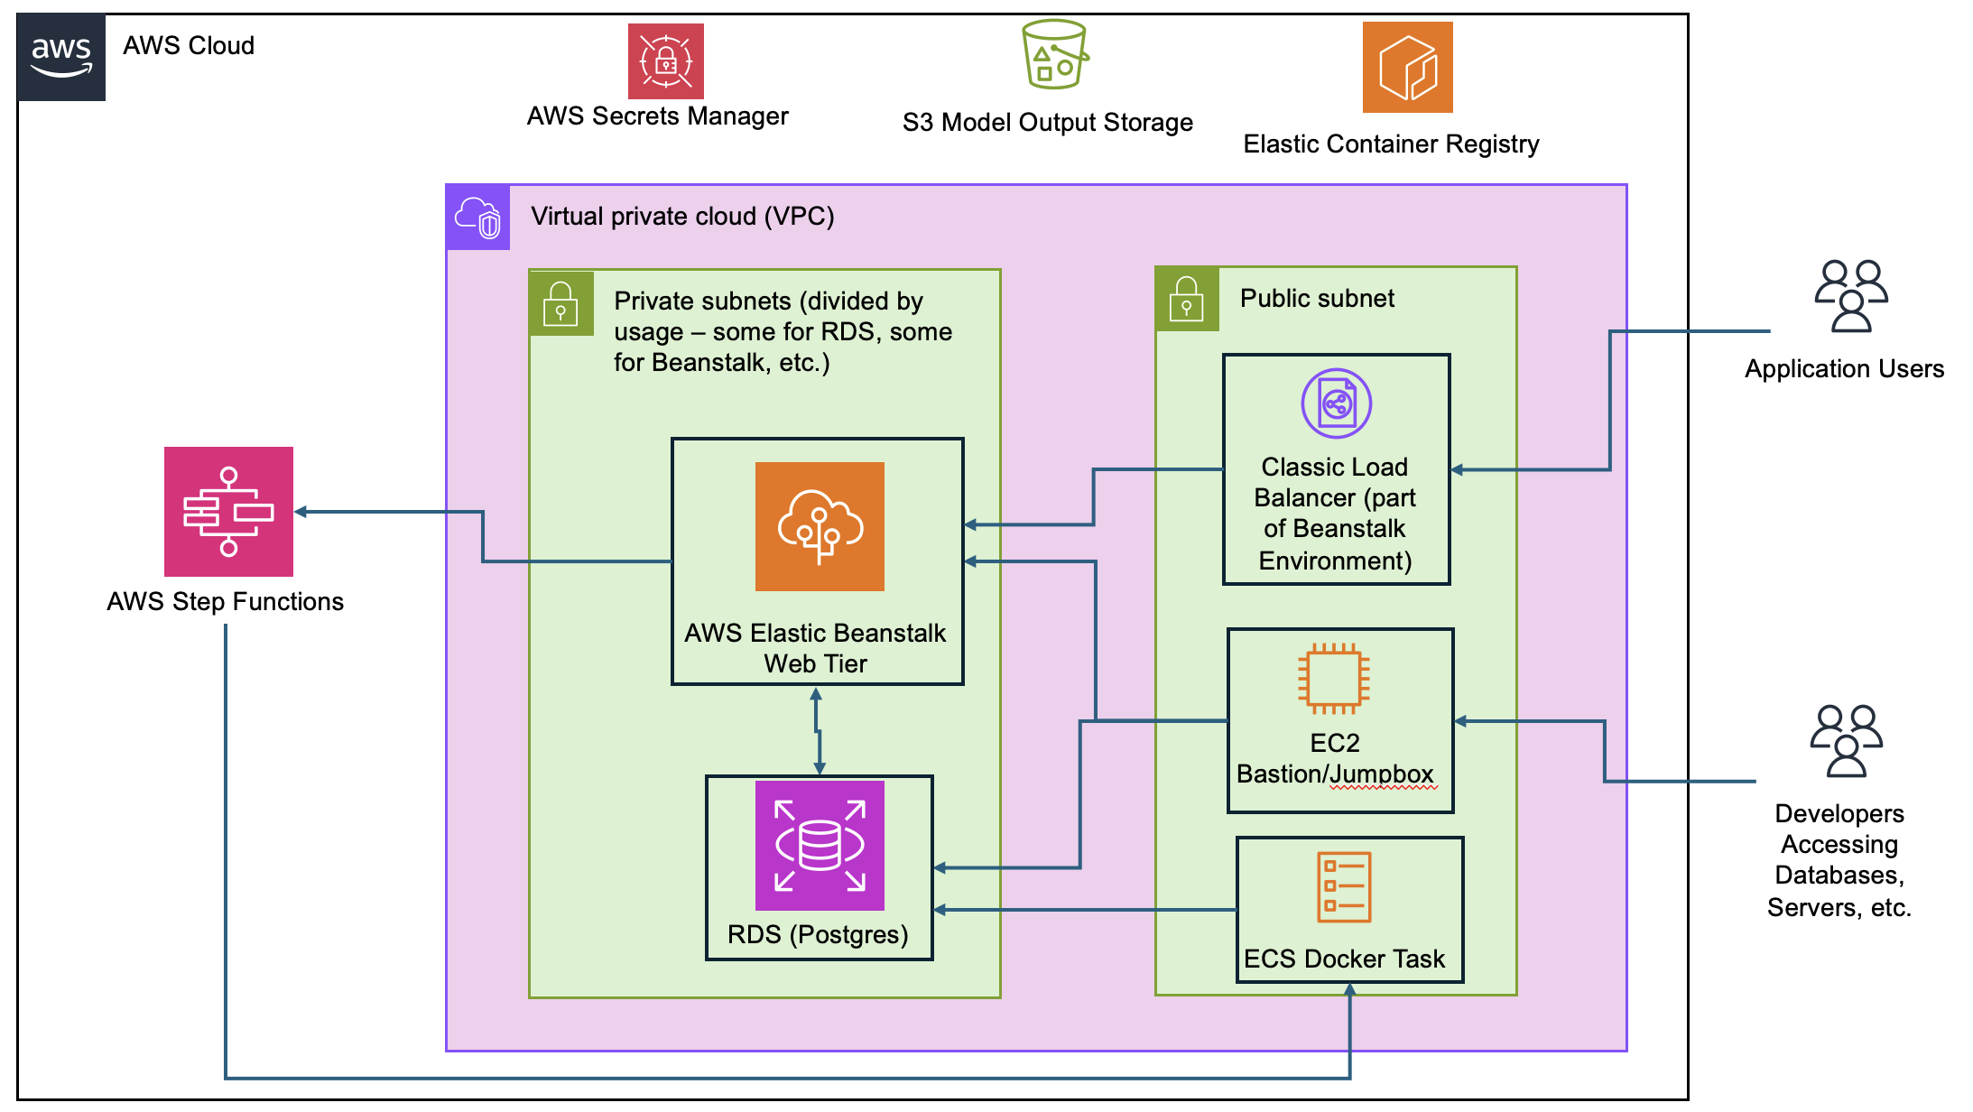

The highlights of the architecture are pictured above and overview of the main changes are described below:
- As before, Elastic Beanstalk runs the web tier of the application, written in Python/Flask.
- RDS instance is now standalone and runs in a private subnet.
- A EC2 bastion/jumpbox in the public subnet is now available; developers or external tools needing direct access to the RDS instance, the provisioned EC2 instances managed by Beanstalk, etc., can ssh tunnel to them through the bastion. Details below.
- When a model run is requested, web tier executes a Step Function, which instantiates and runs a Docker task via Elastic Container Service.
  - The Docker task is just a thin wrapper around existing Python code. It runs, writes results to the database, and dumps output files to an S3 bucket.
- AWS Secrets Manager is used for holding database credentials.
- Elastic Container Registry hosts the images used for provisioning Docker containers.

Docker Overview

Code
The code for Docker lives in the “docker” subdirectory in the repository, located at https:// github.com/ICF-Corp/trim-builder.git. In general the deployment script can be used for updating and deploying the Docker image, but for detail here is a roundup of the four files in this directory:

- Dockerfile – based on 3.11 Alpine Linux, with all necessary packages that PyTRIM needs to run installed.
- requirements.txt – used by the Dockerfile in a “pip install” during image creation.
- _entrypoint.py – copied into the Docker image and used as the actual command that the Docker container runs on startup. This is a quick shim/wrapper that builds a fake context, sets some environment variables, and hooks into the relevant part of the Python code to perform a model run. Also responsible for dumping output files to the S3 bucket.
- prepare_dockerized_pytrim.py – a Python script that takes all the PyTRIM code and _entrypoint.py and builds a directory structure that the Dockerfile can then use when building the image.

IaC / Deployment Script Overview

Code
The “Infrastructure as Code” portion of the updates lives in the “iac” subdirectory of the repository. An overview of the files:

File/Directory | Explanation
src/cloudformation/ | the CloudFormation YAML template that describes the AWS resources to be deployed. This could be used manually in the AWS console but is also utilized by the deployment script which is frankly more convenient.
src/deployer/ | a Python 3 script that can be used to build the Docker container, deploy the system initially, make infrastructure updates, and push out builds to the web tier and Docker container registry.
requirements.txt | Python requirements (e.g. “pip install -r requirements.txt”) sufficient for use in running src/deployer/pytrim_deploy.py. To be clear, this is NOT sufficient to actually run the main PyTRIM web application; this is enough to run pytrim_deploy.py

Deployment Script

Setting Up the Deployment Script
The deployment script is a Python 3 script that can be used to initially deploy the AWS infrastructure the system uses, deploy infrastructure updates, build the Docker application, push Elastic Beanstalk builds, etc. As mentioned above, the file “iac/requirements.txt” can be used with a Python virtual environment and pip to install required packages, e.g.:

pip install -r requirements.txt

Configuration File
The deployment script requires a configuration file with various values set in it. The structure is included here along with an explanation of the various values. This file is NOT committed to source control as it contains database credentials; see a developer on the project to get the current one.

{
"environment_name": "",
"short_env_profile": "",
"aws": {
"ssh_keypair_name": "",
"eip_name": "",
"cidr_segment_vpc": -1,

"ec2_ingress": [
{
"description": "",
"cidr": ""
}
],

"db": {
"dbname": "",
"username": "",
"password": ""
}
}
}

Configuration Key | Explanation
environment_name | This value will be used as both the name of the CloudFormation stack to be created, and as a prefix on the names of most other AWS resources, e.g. “<environment_name>_vpc”. It can contain alphanumeric characters and dashes but no underscores; any value is acceptable here. (all resources of the stack can of course be viewed via the CloudFormation console.)
short_env_profile | Shorter environmental name used by the application code to determine if it is running in dev or prod mode. “dev” or “prod” should be used for AWS development or production instances; the main thing this will determine is if the application should use Docker for model runs or not. Any other value can be used for local development.
aws.cidr_segment_vpc | This will be used when constructing the VPC containing the resources for this system. For instance, a value of 99 here will yield an IPv4 CIDR for the VPC of 10.99.0.0/16. This should be a legal value that is not currently in use by any other VPCs on the account you use to deploy the system. (the deployment script will also check to ensure this is not a value already in use).
aws.ssh_keypair_name | If you have a previously created AWS EC2 keypair that you wish to use, you can specify the name here. If a keypair by this name does not exist, one will be created and a .pem file will be created in output/ssh_key/. This can be used if you wish to ssh through the bastion into the EC2 instances that Elastic Beanstalk provisions, or to tunnel to access the RDS instance.
aws.eip_name | If you have an available AWS EC2 Elastic IP that you wish to use, you can specify the name (NOT the allocation id) here. If an elastic IP by this name does not exist, one will be created. If it exists but is in use, the deployment script will notify you accordingly.
aws.ec2ingress.cidr | Specify the CIDR that you wish to have access to the EC2 bastion instance for e.g. ssh connectivity. Multiple cidr/description objects are supported.
aws.ec2ingress.description | Readable description for the CIDR range, e.g. “my home IP”, “company VPN”, etc.
aws.db.dbname | Name to use for the RDS instance
aws.db.username | Username for the RDS instance
aws.db.password | Password for the RDS instance

AWS Credentials
The deployment script uses the AWS SDK for Python (Boto3) to interact with AWS. Before running it, you will need to configure your AWS credentials for the account you want to deploy resources on. How to do so is outside the scope of this document; see https://boto3.amazonaws.com/v1/documentation/api/latest/guide/credentials.html for details. AWS SSO was used during development but any supported approach (AWS profile, shared credential file, etc.) should work.

The deployment script will display the user/account it has identified you as during startup so that you can be sure which account you are working with.

Deployment Modes
The deployment script is executed by running a command like:

python pytrim_deploy.py -c <path_to_config_json> (-m <mode>)

The available modes are as follows; if the mode parameter is omitted it will default to “full”. “ssh-key” and “elastic-ip” (and so, “full” as well) are unlikely to be used beyond initial application deployment in a new environment; “cloudformation”, will be used infrequently but not uncommonly; “docker” and “push_flask_build” should be used any time model running code or website code is updated and ready for deployment.

Mode | Description
full | Runs all the following modes, except push_flask_build, in the listed order.
ssh-key | Checks for existence of configured ssh keypair; creates and saves .pem if necessary.
elastic-ip | Checks for existence and availability of configured elastic ip name; creates if necessary.
cloudformation | Deploys or updates CloudFormation stack
docker | Builds the Docker image and pushes it to ECR. Note that you must have a Docker install locally to perform this.
push_flask_build | Packages up the files to deploy the latest build to Elastic Beanstalk.

Dockerized Model Run Explanation

Entrypoint

See Scripts/trim_frontend/scenarios/routes.py::run_result_scenario. This has been modified; if an environment variable of TRIM_ENV_PROFILE is present and set to “dev” or “prod”, it will trigger the Dockerized flow. This environment value will be set on Elastic Beanstalk instances if the appropriate short_env_profile value was set in the config file used by the deployment script. If any other value is present (or the variable is missing entirely), then the app will revert to original behavior and run the model on its own without Docker. This can be useful for local development when you don’t want to bother with Docker deployments.

Dockerized Flow Explanation

Assuming TRIM_ENV_PROFILE was set, here’s what happens:

- run_result_scenario will start execution of the AWS Step Functions state machine created by the deployment script:
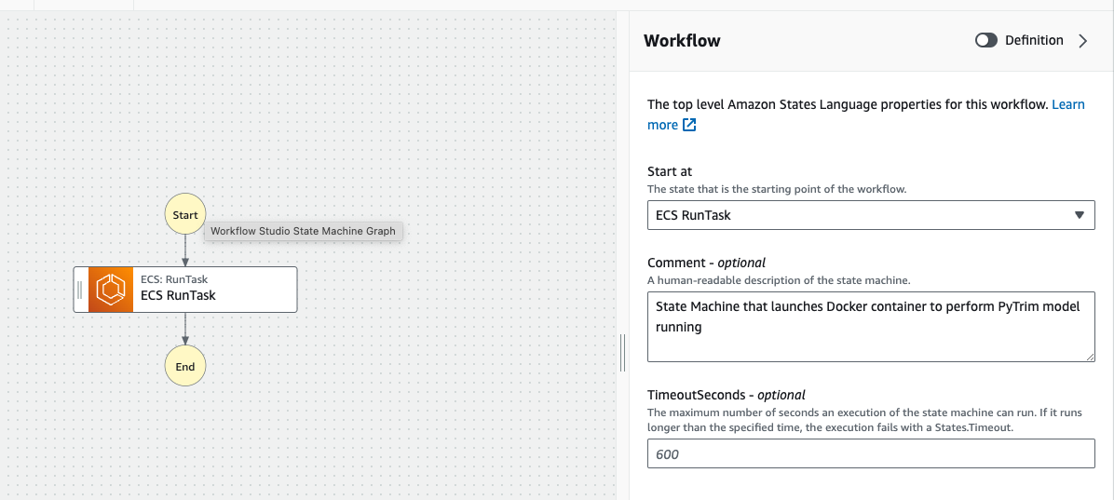

- This state machine has a single step which executes an Elastic Container Service task. The API parameters and the “wait for callback” option are the important bits. This is all set up by the deployment script:
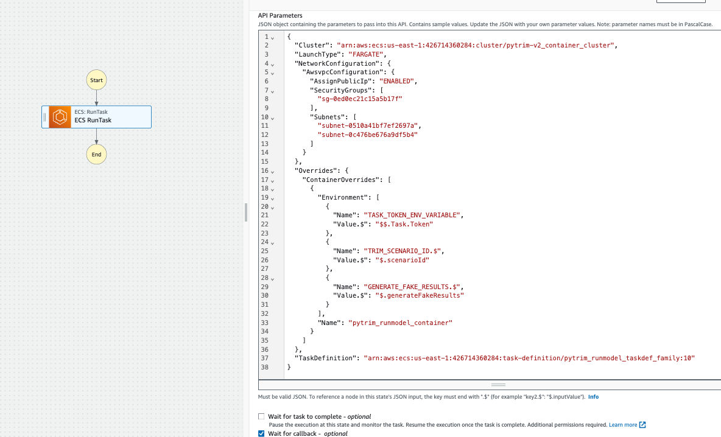

- The Elastic Container task spins up a Docker container from the published image. routes.py passes a scenario id as part of it’s invocation of the step function. The step function configuration of the task puts that scenario id into the Docker container as an environment variable. The Docker container reads that scenario id, sets up just enough of an environment to run, and kicks off the run. The database gets updated as it proceeds. When it’s done, it will write output files to S3. A successful execution looks like this:

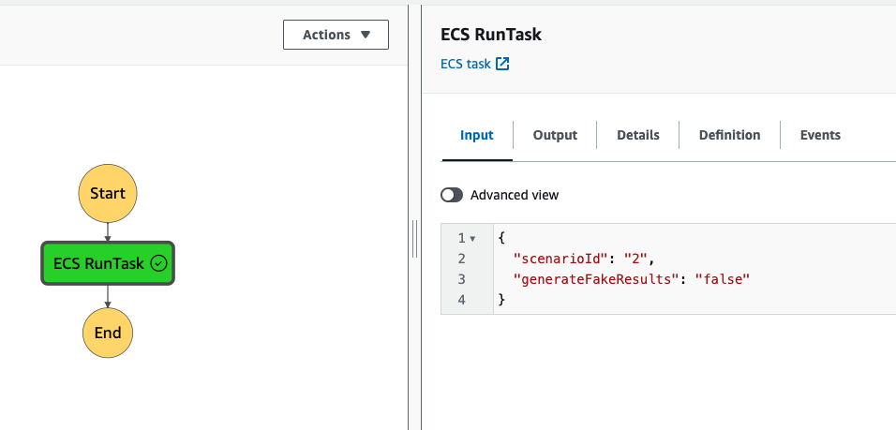

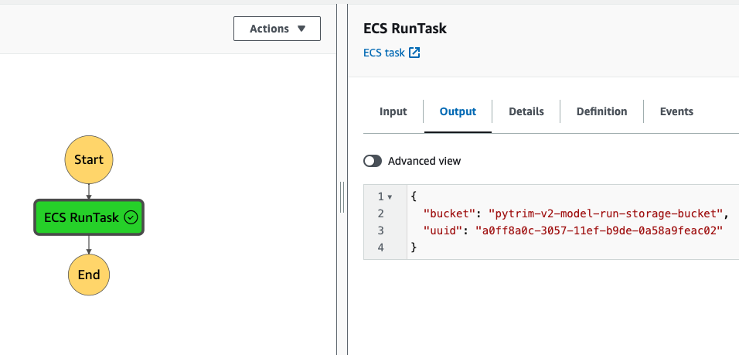
- Currently the user-facing webpage polls periodically to see if the run is done; once it is it receives the output of the Step Function to link the user to results. It would be a nice future enhancement to store the uuid and status of ongoing runs so a user could revisit the page, be emailed on run completion, etc.

Docker Scaling

The Docker instance currently runs on AWS FARGATE (serverless). If you want to run a beefier instance, edit the “DockerTaskDef” resource in the CloudFormation template (that controls CPU and memory) and run the deployment script with mode “cloudformation” to deploy the infrastructure update.

Having said that – as of July 2024, the bottleneck on model run speed appears to be related to database access via the ORM (ongoing modifications in that area appear to be making improvements) so bigger instance are unlikely to increase speed much. During testing of the Dockerized architecture it made very little difference when scaling up past a certain point. But, if the need ever arises, that’s how you’d do it.

Docker Local Testing

If you need to run the Docker machine locally to troubleshoot any issues, you can build an image from the Dockerfile (e.g. “docker build -t pytrim_poc .”) and then do something like so:

docker run -w `pwd` -v `pwd`:`pwd` -e TASK_TOKEN_ENV_VARIABLE='IGNOREME' -e TRIM_SCENARIO_ID=<scenario_id_to_test> -e RDS_HOSTNAME=host.docker.internal -e RDS_USERNAME=root -e RDS_PASSWORD= -e RDS_PORT=3306 -e RDS_DB_NAME=pytrim -e SECRET_KEY=dcf917c34aec178987494a853bffa479 -e SQLALCHEMY_DATABASE_URI="mysql+pymysql://root:@host.docker.internal:3306/pytrim" --name some_container_name -dit pytrim_poc

That’s a lot of stuff! Commandline args explained. Note the backtick! Windows users may need to modify; this was done on OSX.

Arg | Explanation
-w `pwd` | Set Docker directory to working directory
-w `pwd`:`pwd` | Mount the current directory as a volume; lets the container write files that persist.
-e TASK_TOKEN_ENV_VARIABLE=’IGNOREME’ | Set environment variable; used when running within AWS Step Function / ECS context
-e TRIM_SCENARIO_ID=2 | Another environment variable; scenario id to process
-e RDS_HOSTNAME, -e RDS_USERNAME, -e RDS_PASSWORD, -e RDS_PORT, -e RDS_DB_NAME | More environment variables, details of the RDS instance. Could be either a local MySQL, tunneled dev instance, etc.
--name some_container_name | Arbitrary container name
-dit | d==run in background; i==keep STDIN open; t==allocate a pseudo TTY
pytrim_poc | Name of the image you built

Then use e.g. “docker attach some_container_name”, “docker logs some_container_name”, etc. to see what’s going on.

Troubleshooting / Logging / etc.

Logs

If CloudFormation stack creation or update fails, consult the event logs in the AWS CloudFormation management console. Attempts have been made to make the deployment script fault-tolerant and forgiving, but in a platform as complex as AWS it is virtually impossible to anticipate every possible problem. But for instance if you are over the quota for elastic ip’s, running the script as a user w/o sufficient permissions, etc. – the CloudFormation console event logs for the stack should point you in the right direction.

Accessing the private instances

To troubleshoot, view script logs, etc. it is useful to know how to access the EC2 or RDS instances. Visit the AWS EC2 console and note the public IP and instance id for the Bastion instance. You can then connect in various ways, such as:
- ssh: ssh -i <path_to_saved_pem> ec2-user@<bastion_public_ip>
- AWS Systems Manager CLI: aws ssm start-session --target <instance_id>

Once you’ve verified that you can connect to the Bastion directly (if you have trouble, verify that the security group for the Bastion includes your IP in its allowed inbound rules), you can then tunnel through it to the host you are trying to hit. For example, if you wanted to access the MySQL instance you could do something like this on a Mac:
- Add an entry in your .ssh/config file like:
Host pytrim_dev_jumpbox
# elastic ip of the jumpbox for the PyTrim
HostName <public_ip_of_bastion>
User ec2-user
Port 22
IdentityFile </path/to/keypair.pem>

- Open an ssh tunnel; 2005 is a monitoring port for autossh. 3306 is default MySQL port. 6603 is an arbitrary open port on your system. Update as necessary.
autossh -M 20005 -N -f -L 6603:<public_hostname_for_RDS_instance>:3306 pytrim_dev_jumpbox

- You can then access by doing something like:
mysql -h127.0.0.1 -P 6603 -u <dbuser> -p<dbpass> <dbname>

Similar steps can be followed using tools like PuTTY, MySQL Workbench, etc.

Uninstallation

The deployment script does not support uninstallation. Instead, just visit the AWS CloudFormation console and delete the appropriate stack. This will delete everything other than the related ssh keypair and elastic ip; if those were created they would need to be deleted manually via the EC2 console.

You may have to empty any S3 bucket for stack deletion to complete successfully.

